YENNYUYGHA PASCAL, MOUNGANG JOEL

MINAC  Yaounde, Cameroon

2024

**Design Document MINAC Statistical Database System**



**Project Title: MINAC Statistical Database Management System Implementation.**

Project Manager: Mme Wangue née Sotong Dimoli Ndoumbe Nadége Aurélie.

Head of Statistics and Data Processing Unit

Project Supervisor: Eng. Tanwi Nkiamboh

Project Start Date: 11 March 2024

Project End Date: 11 May 2024

Methodology: Agile

**Table of Contents**

**1.** **Project Goals** 3

**3.** **Requirements** 3

**4.** **User Personas** 3

**4.1** **Administrators:** 3

**4.2** **Users:** 3

**5.** **Wireframes and Mockups** 4

**5.1**  **User Interfaces:** 4

**7.** **Technical Specifications** 7

**8.** **Design Decisions and Rationale** 7

**9.** **Design Iterations and Feedback** 7

**Figure 1: Data Entry Form** 4

**Figure 2: Edit Data Entry Form** 4

**Figure 3: Printing Options** 4

**Figure 4: Printing Form** 4

**Figure 5: Report Form** 5

**Figure 6: Update and Delete Options** 5

**Figure 6: Login Form** 6

**Figure 6: Sign Up Form** 6

**Figure 6: Homepage Form** 6

# **Project Goals**

The MINAC Database Management System aims to develop a comprehensive database management system to store and manage statistical data related to arts and culture.

1. **Project Scope**

- The system will enable users (admins) to Create, Read, Update, and Delete (CRUD) statistical data entries.

- Super admin will have the ability to add new users or give admin privileges to some.

- Users will have the ability to generate and print reports based on the stored data.

# **Requirements**

- Secure user authentication and authorization mechanisms.

- Data import/export functionality for seamless integration with existing systems.

* 1. **Use Cases:**

- Super Admin: Manage user roles, access permissions, and system settings

- Admin: CRUD operations for data management, generate reports

- End User: Search, view, and export relevant information

# **User Personas**

## **Administrators:**

* Responsible for inputting new statistical data into the system.
* Engage with the system to review, update, and generate reports based on the stored data.

## **Users:**

* Engage with the system to view, search, and export relevant information based on stored data.

# **Wireframes and Mockups**

Visual representations of the user interface, showcasing data entry forms, report generation interfaces, and printing options.

## **User Interfaces:**

**Figure 2: Edit Data Entry Form**

**Figure 1: Data Entry Form**

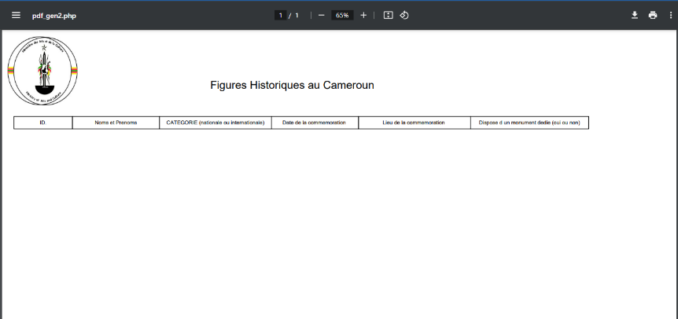

**Figure 4: Printing Form**

**Figure 3: Printing Options**

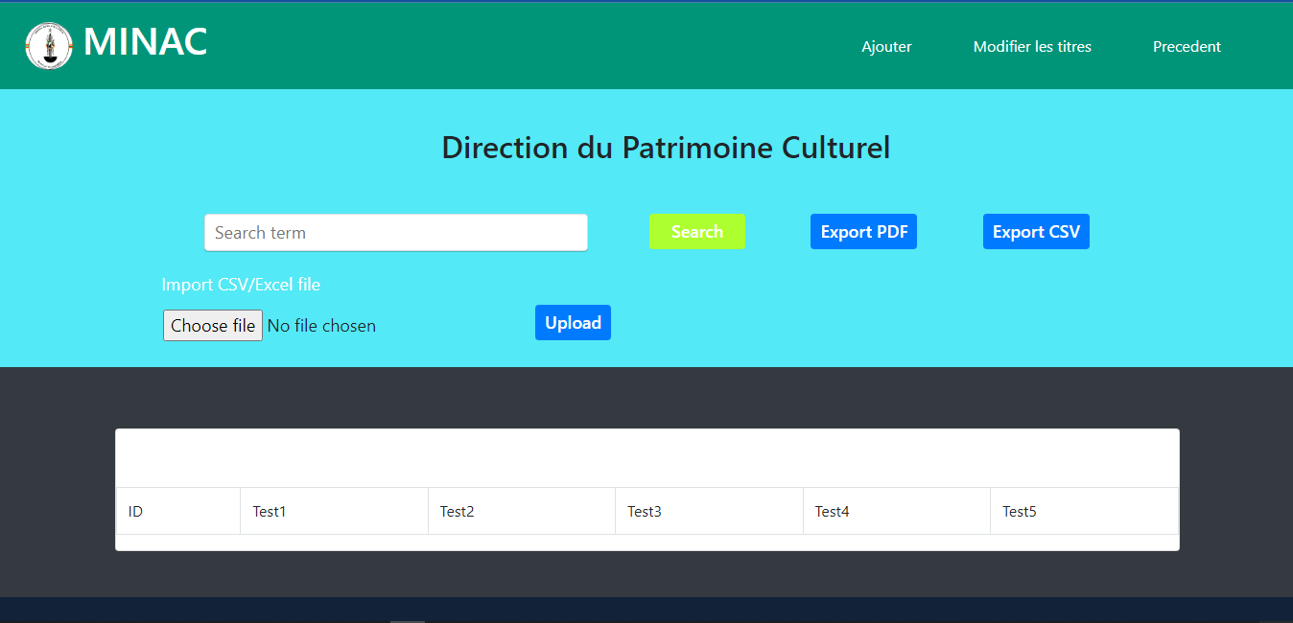

**Figure 5: Report Form**



**Figure 6: Update and Delete Options**

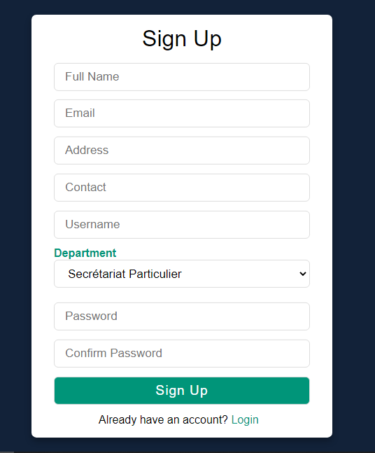

**Figure 7: Login Form**

**Figure 8: Sign Up Form**



**Figure 9: Homepage Form**

1. **Design Guidelines**

- Consistent use of color coding for different types of statistical data.

- Intuitive navigation and clear information hierarchy to facilitate user interaction.

# **Technical Specifications**

- Utilization of a secure backend database to store sensitive statistical information.

- Integration with a reporting framework to facilitate report generation and printing.

# **Design Decisions and Rationale**

- Choice of a tabular layout for data entry forms to streamline input processes.

- Implementation of print-friendly templates to ensure legible and professional-looking reports.

# **Design Iterations and Feedback**

- Iterative refinement based on usability testing with end users to ensure ease of data entry and report generation.

- Incorporation of feedback from stakeholders to enhance system functionality.